INTRODUCTION TO CYBERSECURITY

IP ADDRESSING
TASK1: Find the IP address of your computer or mobile device and write down whether it is IPv4 or IPv6. Also mention if it is a public or private IP.
- Press Windows + R.
- Type: cmd
- Press Enter.
- Type: ipconfig
- Press Enter.
- Look under your active Wi-Fi or Ethernet adapter.
- Find the IPv4 Address.
EXAMPLE:
IPv4 Address : 10.133.23.106
• IP Address: 10.133.23.106.
• Type: IPv4
• Category: Private IP
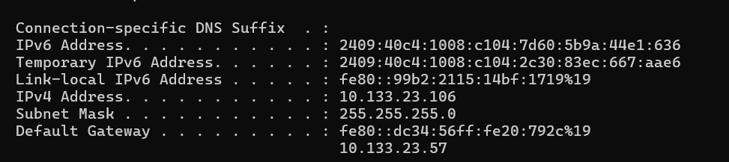
TASK2: Given the following list of IP addresses, identify which ones are valid private IPs and which are public: 192.168.1.10, 10.0.0.5, 172.16.5.20, 8.8.8.8, 123.45.67.89.<br><br><em><strong>Hint:</strong> Check the standard private IP address ranges for IPv4.</em>
Private IPv4 Ranges
There are three standard private IPv4 ranges:
10.0.0.0 – 10.255.255.255
172.16.0.0 – 172.31.255.255
192.168.0.0 – 192.168.255.255
IP Address | Type | Reason
192.168.1.10 | Private | Comes under 192.168.0.0/16
10.0.0.5 | Private | Comes under 10.0.0.0/8
172.16.5.20 | Private | Comes under 172.16.0.0/12
8.8.8.8 | Public | Not in any private range
123.45.67.89 | Public | Not in any private range

TASK3: Write a short script in Python or JavaScript that takes an IP address as input and tells the user whether it is a valid IPv4 address or not.<br><br><em><strong>Constraint:</strong> Do not use any third-party libraries for validation.</em>
- Open Python IDLE, VS Code, or any Python editor.
- Create a new Python file.
- Write the following code:
ip = input("Enter an IP address: ")

parts = ip.split(".")

if len(parts) == 4:
valid = True

for part in parts:
if not part.isdigit() or int(part) < 0 or int(part) > 255:
valid = False
break

if valid:
print("Valid IPv4 address")
else:
print("Invalid IPv4 address")
else:
print("Invalid IPv4 address")
4. Run the program.
5. Enter an IP address when asked.
TASK4: Explain with an example how Instagram or WhatsApp might use IP addresses to detect suspicious login activity from different locations.
Example – Instagram
Suppose I normally use Instagram from India. My usual login may come from an IP address associated with India.
One day, Instagram detects a login from an IP address associated with a different country, for example the USA, within a short time.
Instagram can compare the IP address and location with my previous login activity. If the change looks unusual, it may send a security alert, ask for verification, or require additional authentication.
